Dandenong & District Historical Society
Annual Report
2018/19

Contents

Mission Statement
Goals 2018/19
Goals 2019/20
Executive Committee and Volunteers
Sponsors and Donations 2018/19
DDHS Statistics
Membership
Membership meetings
Presidents Report
Treasurers Report
IT Report
Editors Report

Mission Statement
The Society’s mission and purpose is to collect, document, research, preserve and make available to the wider community for their enjoyment and education items that show the development of the Dandenong District from early settlement to present day.

Goals 2018/19
- Digitisation of Collection
- Cataloguing of Photo Albums
- Cataloguing of Vertical Files
- Cataloguing of Hanging Files
- Long Range Plan
- Executive Committee Code of Conduct

Goals 2019/20
- Digitisation of Collection
- Cataloguing of Vertical Files
- OH&S assessment
- Long Range Plan
- Executive Committee Code of Conduct
- Review Business Plan
- E Hive training
- Uploading collection onto eHive
- Four local history lectures
- Seniors Week Heritage tour
- Characters of Laurel Lodge presentation

Executive Committee and Volunteers

Volunteers’ lunch
Dec 2018 with
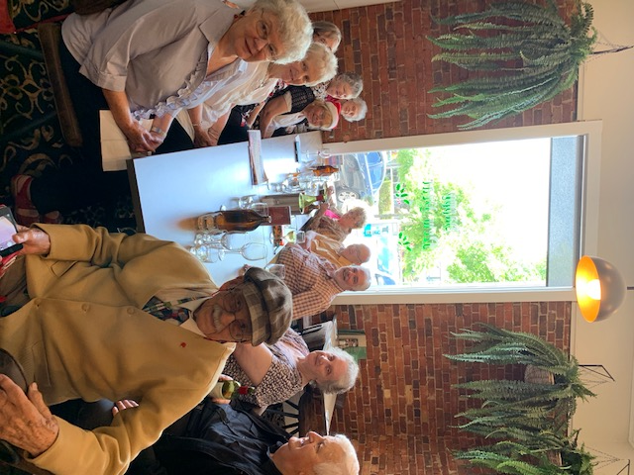
Alf our paper boy OA.
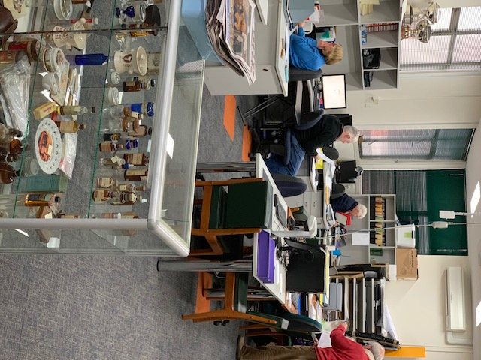

Executive Committee  The following persons were members of the Executive Committee during the financial year and up to the Annual General Meeting scheduled for 20 October 2019  - Chris Keys, President  - Christine Ware, Vice President  - Jenny Ferguson, Secretary & Public Officer  - Ken Masters, Treasurer  - Shirley Constantine  - David Nassau  - Tom Stein  - Lorraine Webb | Volunteers  - Ray Carter  - Jenny Ferguson  - Gwenda Fleming  - Alf Goldburg  - Judy Grant  - Chris Keys  - Ken Masters  - David Nassau  - Bev Pursell  - Yvonne Smith  - Tom Stein  - Pat Taylor  - Lorraine Webb  - Margaret Weightman

Executive Committee Meetings 2018/19

The Executive Committee met on four occasions during the financial year.
1 August 2018, 31 October 2018, 27 February 2019, 22 May 2019,

Committee Member | No of Executive Committee meetings held
 | Meetings held | Meetings attended
Chris Keys | 4 | 4
Christine Ware | 4 | 3
Jenny Ferguson | 4 | 4
Ken Masters | 4 | 3
David Nassau | 3 | 2
Carmen Powell | 1 | 0
Shirley Constantine | 4 | 2
Tom Stein | 4 | 4
Lorraine Webb | 3 | 2
Margaret Weightman | 1 | 0

Sponsors and Donations 2018/19
In excess of $250.00
City of Greater Dandenong
Dandenong Club
Bill & Elaine Montague

DDHS Statistics
1 July 2018 to 30 June 2019

Rooms  Equivalent days worked by volunteers for DDHS rooms during the year:  435 days | Researchers  Total number of researchers attended rooms: 82 | Research  Total number of research projects volunteers worked during the year:
Acquisitions  Total number of acquisitions: 27 | Speaking Engagements  Total number of speaking engagements: 6 | Speaking Engagement Hours  Total number of hours on research writing and creating and presenting:120
Exhibitions  Total number of  Exhibitions:3 | Exhibitions  Total number of hours researching and curating: 100 | Dandenong Journal  Total number of hours on researching and writing articles: 71
Community Activities  Number of community and association meetings attended: 11 | Gipps-land Gate  Total number of hours researching & writing: 162 | Volunteer Hours  Total number of hours contributed by  Volunteers:3284

Web Site
Visits during the period 1 July 17 to 30 June 18
- Number of unique visitors 1663
- Number of page views 7368
- Oct is the least active month
- Aug is the most active month

Membership

- Total no of members as at 1 July 2018:132
- New members during year: 7
- Members ceased during the year: 11
- Total no of members as at 30 June 2019:128

Meetings Held During 2018/19

- 19 August 2018
Trish Keilty founder of Avocare spoke to 20 members and friends at 39 Clow Street talk passionately about the work of Avocare in the City of Greater Dandenong. Avocare run a not for profit organisation in the foods distribution and training for unemployed.
- 21 October 2018 - Annual General Meeting
After the AGM 25 members and friends heard Lorraine Webb give a most interesting talk on Ripponlea. Her story brought the house and garden to life as she virtually walked around the home and garden.
- 2 December 2018
Christmas Lunch was held at the Dandenong Club and was attended by 43 including the Mayor Cr Ros Blades and Cr’s Tim Dark and Matthew Kirwan.
- 17 February 2019
Jenny Ferguson organized a “meet the volunteers” with the DDHS volunteers informing the attendees what they did each week. Tom Stein took a personalised tour of the Collection and then Carmen Powell, David Nassau, Ken Masters, Ray Carter, Bev Pursell, Alf Goldburg, and Jenny Ferguson talked about their individual responsibilities.
- 28 April 2019
Stana Sargood enthralled the audience of 37 on the inner workings of the Dandenong Festival of Music and Art for youth.
- 15 June 2019
70 people attended the annual lunch held at the Dandenong Club and were richly blest by Martin Culkin, ex Principal of Dandenong High School, as he described the rationale and process of combining three schools into one.

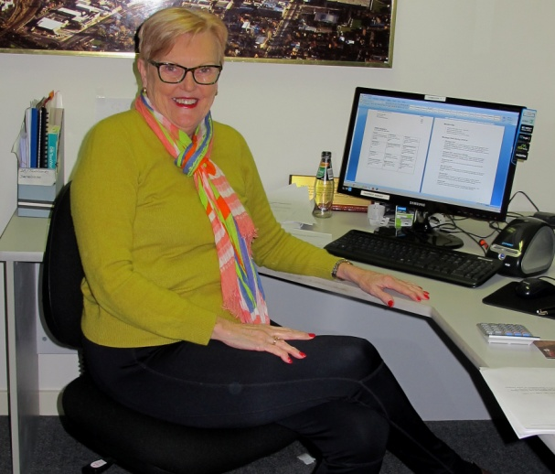
President
Chris Keys

Executive Committee
The Executive Committee met four times during the year and developed and approved the following policies:

- Annual Report to the City of Greater Dandenong
- Risk Management statement
  - Volunteer training
  - Succession Planning
  - IT expertise

I would like to thank the members of the Executive Committee who worked on these documents to ensure that we conformed to legislation and moved our policies towards best practice levels.

Events & Community involvement
I have been privileged to attend meetings, exhibitions and events on behalf of the Society and thank all concerned for the opportunity to hear, see, and be involved in our Community.
- Tenants meetings 39 Clow Street
- Monash University WW1 remembrance and posthumous award Ceremony
- Open House Dandenong Town Hall
- Exhibition at Dandenong Show
- Exhibition at Benga
- Speaker at U3A

Cultural Heritage Advisory Committee
This committee commenced on 27 April 2017 and has been meeting bi monthly since then. I was honoured to be elected Chair of this important committee. A report to the Council was made in July 2019. And advised the Council on the following:
- public Art in Springvale Hub and Library
- formation of space allocated to SDHS in the Springvale Hub and Library
- needs for storage to maintain the historical collections of the CoGD
- new collections policy for the civic collection
- 25 year history of City of Greater Dandenong
- preservation of the Noble Park 100yr exhibition

Finance
Ken Masters works at the rooms every week to make sure that the income and expenditure is accounted for in accordance with the legal requirements. Each year there is additional work to be included and this year has been no exception. Ken has decided to retire as the Treasurer of our Society at the next AGM. I would like personally acknowledge the work Ken has done to ensure that I do not have to worry about our finances.
Speaking Engagements
Open House: History of the Dandenong Town Hall
U3A Speaking engagements have been transferred from February to July in 2018 so we ended up preparing and delivery 8 lectures during the year
- 23 July – the grand old lady
- 30 July – The Gartside family of Dingley
- 6 August – The Tin Shedders
- 13 August – workshop on heritage tour
- .4 February –Before Batman
- 11 February –Events that made Dandenong
- 18 February – Events in Dandenong 1897
- 25 February – Heritage sites of Dandenong

Member meetings
Our six member meetings this year were well supported with an average of 35 attending each meeting. Our attendance at the member meetings does rely on our speakers and we will endeavour to invite appealing speakers to continue growth.
Community Projects
Digitising of the Dandenong Journal
Once again we had the assistance of Avocare Ltd during the year with Judy Grant attending the Avocare premises an additional day a week editing the various projects completed by the attendees at the training centre. The projects ongoing at the centre are:
- Digitising the Dandenong Journal 1958 – 1961
- Digitising the Dandenong Cemetery Records
- Digitising Gippsland Gate
Our aim is to provide our members and researchers with the ability to search our collection via our website.
Looking Back in the Dandenong Journal
We continue to work each week on researching the old papers to collect past items of interest 100yrs, 50yrs, 20yrs, and 5 yrs ago. Feedback from the public indicates the enjoyment these articles provide.
Uploading of Data onto e-hive
e-hive is the storage facility chosen to house records of the collections of City of Greater Dandenong, Springvale & District Historical Society, and DDHS, This is a very large project and will take many hours to complete. Fortunately Yvonne Smith who joined us as a volunteer this year is willing to take on the task of writing procedures for e-hive and then training our volunteers.
Interfaith Network
We are digitising the many photo albums the Interfaith Network have of the history of their organization.

I have had a wonderful year. I always feel excited when I arrive each Wednesday. That first cup of coffee and chat motivates us all. Each week we seem to discover someone new or some new piece of information that is or will become the history of our City. I hope to continue to serve your Society in the years to come.

Chris Keys
President

Secretarial Jenny Ferguson

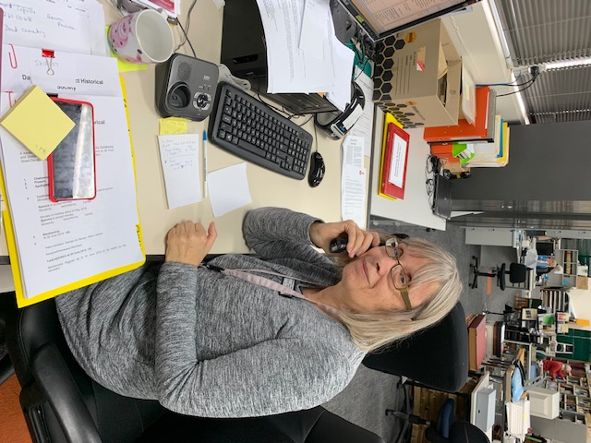

Jenny continues to take on the Role of Secretary/ Public Officer in an incorporated association and does it with a smile. Her duties include:
- All correspondence in and out.
- Production of all committee agendas and minutes.
- Lodging an annual statement within a month after the annual general meeting.
- Applying to Consumer Affairs to change association's name and rules
- Notifying Consumer Affairs
- Changes in association's registered address
- Appointment or changes to details of Secretary
- Any special resolutions to wind up the association or distribute its assets

Not only does Jenny supply her secretarial skills but she makes a great contribution on research, member meetings, and presentations and is the Society’s delegate on the South Eastern Historical Association.

Finance
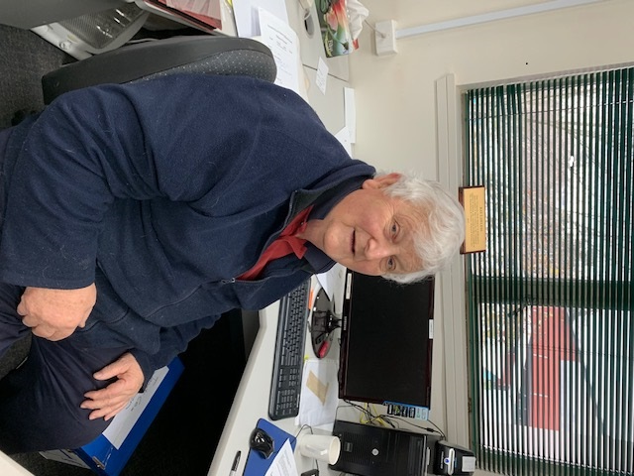
Ken Masters

Once again Ken had the final accounts available at the end of July for the Executive Committee (EC). The EC resolved at their July meeting for the Treasurer to submit the final accounts to the Auditors and records as follows:

- List of Members
- Copies of Agendas and Minutes of
- EC Meetings
- Copy of Agenda and Minutes of AGM
- Bank Statements
- Deposits to Bank
- Cheque Book butts
- Income Receipt Books
- Receipts for purchases
- Expenses, Receipts
- Print outs of Monthly financial accounts
- Petty cash book
- Representation Letter
- Notes to Accounts
- Consolidated Annual Accounts
- Signed total Cash Receipts

Ken does such a fabulous job and is a joy to have around each week.

Following is the Final Accounts for 2018/19 as presented to the Auditor. Audited Accounts available at the AGM scheduled this year for 20 October 2019.

CONSOLIDATED ACCOUNTS
Statement of Receipts and payments
For the year 1st July 2018 to 30 June 2019
RECEIPTS 2013 | 2018 | 2019
Grants  City of Greater Dandenong  Commonwealth Government | Nil  Nil | Nil  Nil
Sponsorships  City of Greater Dandenong  City of Greater Dandenong Utilities  Dandenong Club | 3068  5008  1000 | 3130  5108  1000
Memberships | 1266 | 2842
Functions Annual and Xmas | 3400 | 4379
Books & Publications | 368 | 360
Sale of Photo Album Covers | Nil | Nil
Donations | 718 | 1381
Research, Photographs & Photocopies | 67 | 645
Bank Interest | 56 | 20
Transfer of Newspaper Scanning Account | 5817 | Nil
Miscellaneous | Nil | Nil
Income to 30 June | $20768 | $18865
LESS PAYMENTS

Annual Fees  RHSV & Insurance  Post Office Box  Annual Audit  Consumer Affairs  SEHA  Internet Services | 1009  127  Nil  57  20  720 | 1059  130  660  58  20  720
Donations  Dandenong Agricultural & Pastoral Society | 100 | Nil

CONSOLIDATED ACCOUNTS
Statement of Receipts and payments
For the year 1st July 2018 to 30 June 2019
Payments con't | 2018 | 2019
Equipment Purchases  Optical Digital Scanners  Computers  Computer Equipment  Storage Boxes  Bubble wrap for hanging pictures  Reference material  OKI printer  Security equipment  Intercom system | Nil  1302  Nil  Nil  Nil  Nil  419  Nil  Nil | 1411  Nil  Nil  Nil  Nil  Nil  Nil  562  1067
Service Costs on Photocopier  Computer network maintenance  Restoration of Collection | 1313  835  485 | 1046  Nil  Nil
Consumables  Printer/Photocopier  Stationery  Lateral filing supplies  Dymo labels  Envelopes  Sheet protectors | 493  579  175  Nil  78  Nil | 896  374  Nil  Nil  43  275
Printing  Gippsland Gate  Annual Report | 1199  322 | 1199  Nil
Marketing & Promotions  Annual & Christmas Luncheon  Exhibitions | 3504  597 | 4511  69
Running costs  Telephone  Utilities  Postage  Petty Cash  Sundry | 830  1122  600  250  64 | 705  286  900  200  100
Expenses to 30 June | $16200 | $16291
NET INCOME (DEFICITY) at 30 June | $4568 | $2574

NOTES TO AND FORMING PART OF THE FINACIAL STATEMENTS
FOR YEAR ENDED 30TH JUNE 2019

NOTE 1 – ACCOUNTING POLICIES
- Basis
This financial report is a special purpose financial report as determined by the Executive Committee and prepared for the members of the Dandenong & District Historical Society to satisfy the financial reporting requirements of the Associations Incorporation Act 2012 as amended. No Accounting Standards have mandatory applicability and Statements of Accounting Concepts are also not applicable and accordingly not applied.

The Accounts have been prepared on a cash basis, based on historical cost and do not take into account changing money values or except where stated, current valuation of non-current assets. The accounting policies have been consistently applied, unless otherwise stated.

- Income Tax
The Dandenong & District Historical Society is exempt from income tax as it is considered that its income is not subject to tax under the current income tax legislation.

- Furniture and Equipment
All assets purchased this financial year have been expensed in the Statement of Expenses.

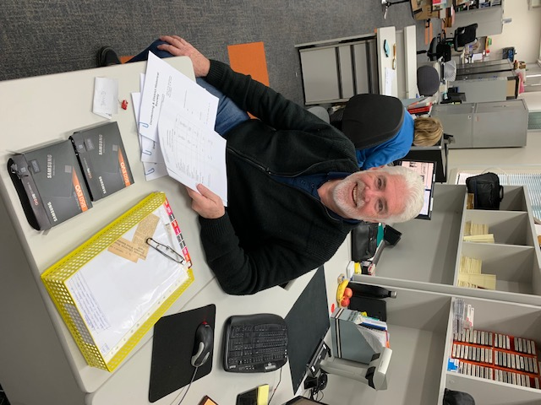
IT Network Administrator

David Nassau is a greatly appreciated volunteer with his expertise in IT he has already made a great contribution to our Society. David has taken on the role of Web administrator along with technical support role. David has made great strides with our new scanners working them to their utmost.

David has also been working with Yvonne Smith in her efforts to get e-hive up and running.

Archiver Administrator
Gwenda Flemming searches the local papers each week for items of interest to future generations. She diligently files these stories into our vertical files or adds them to an existing file. We always ask Gwen when we have researchers in the room if she has seen anything on the researches subject, Colin , Gwen’s husband has designed and made a number of carpentry items to make our job easier, so thanks Colin. Gwenda also make superb sandwiches for our member meetings.

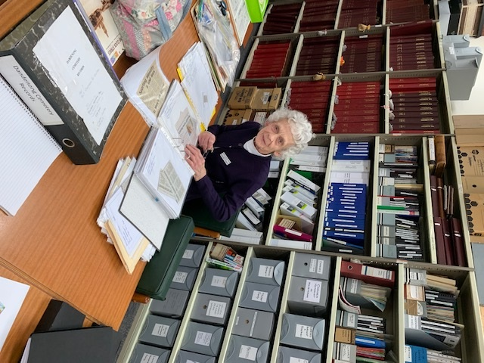

Editor Gippsland Gate

Editorial Committee
With the departure of Carmen at the 30th December 2018 we have appointed an editorial committee consisting of Jenny Ferguson, Lorraine Webb and Chris Keys.

Carmen’s last Gipps-Land Gate was published in October 2018.

October 2018

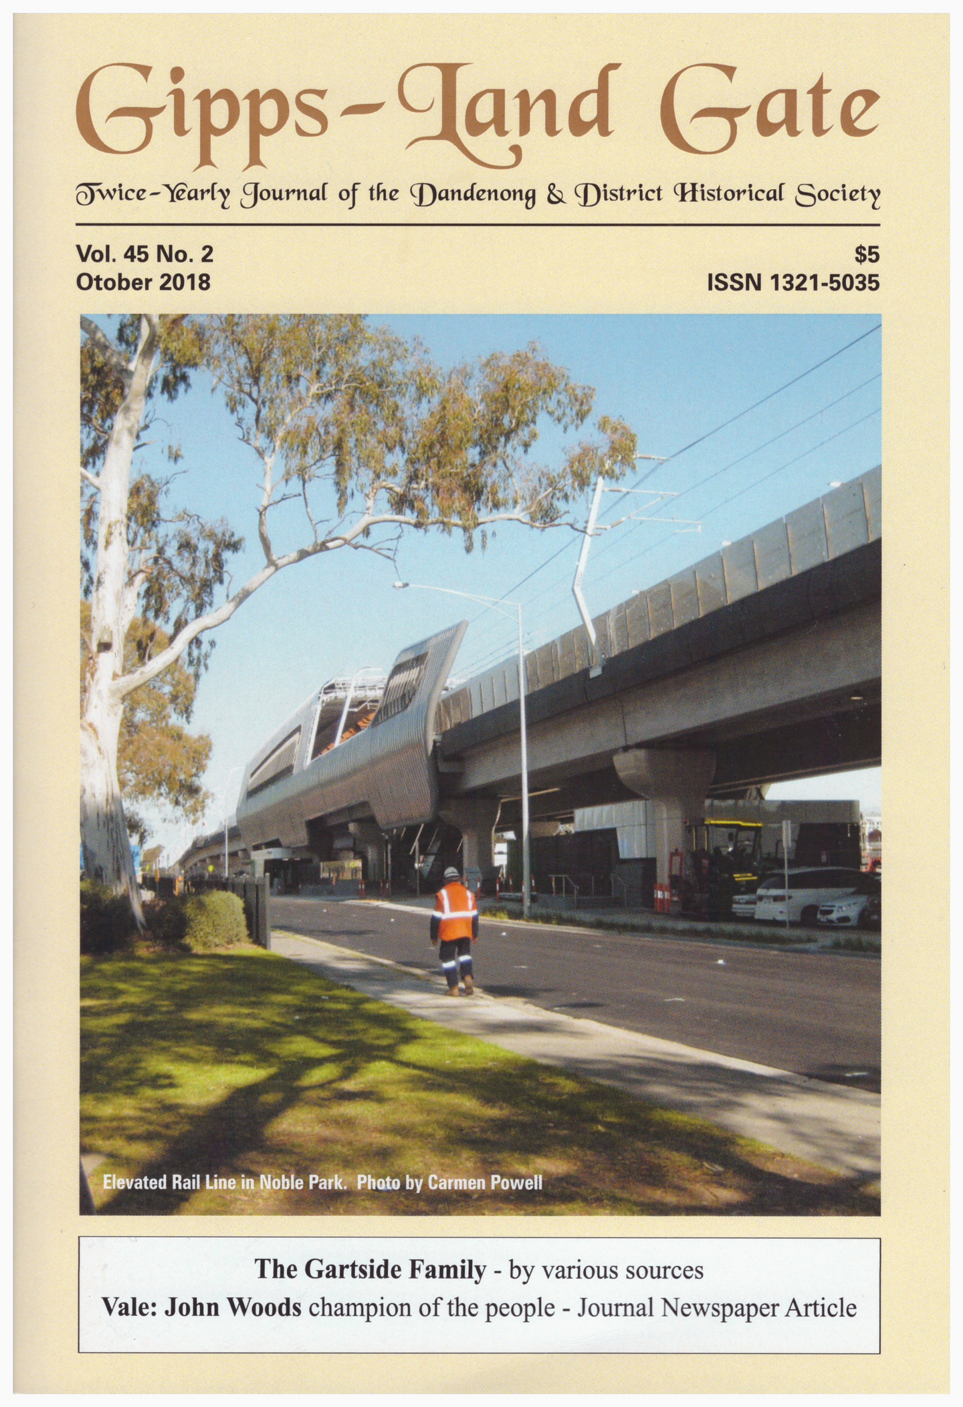

The Gartside Family - Douglas N Gartside
Ken Gartside and French Island – John Woolley
Champion of the people – Vale John Wood
Did You Know? - Carmen Powell
Harking Back – Bev Pursell

April 2019

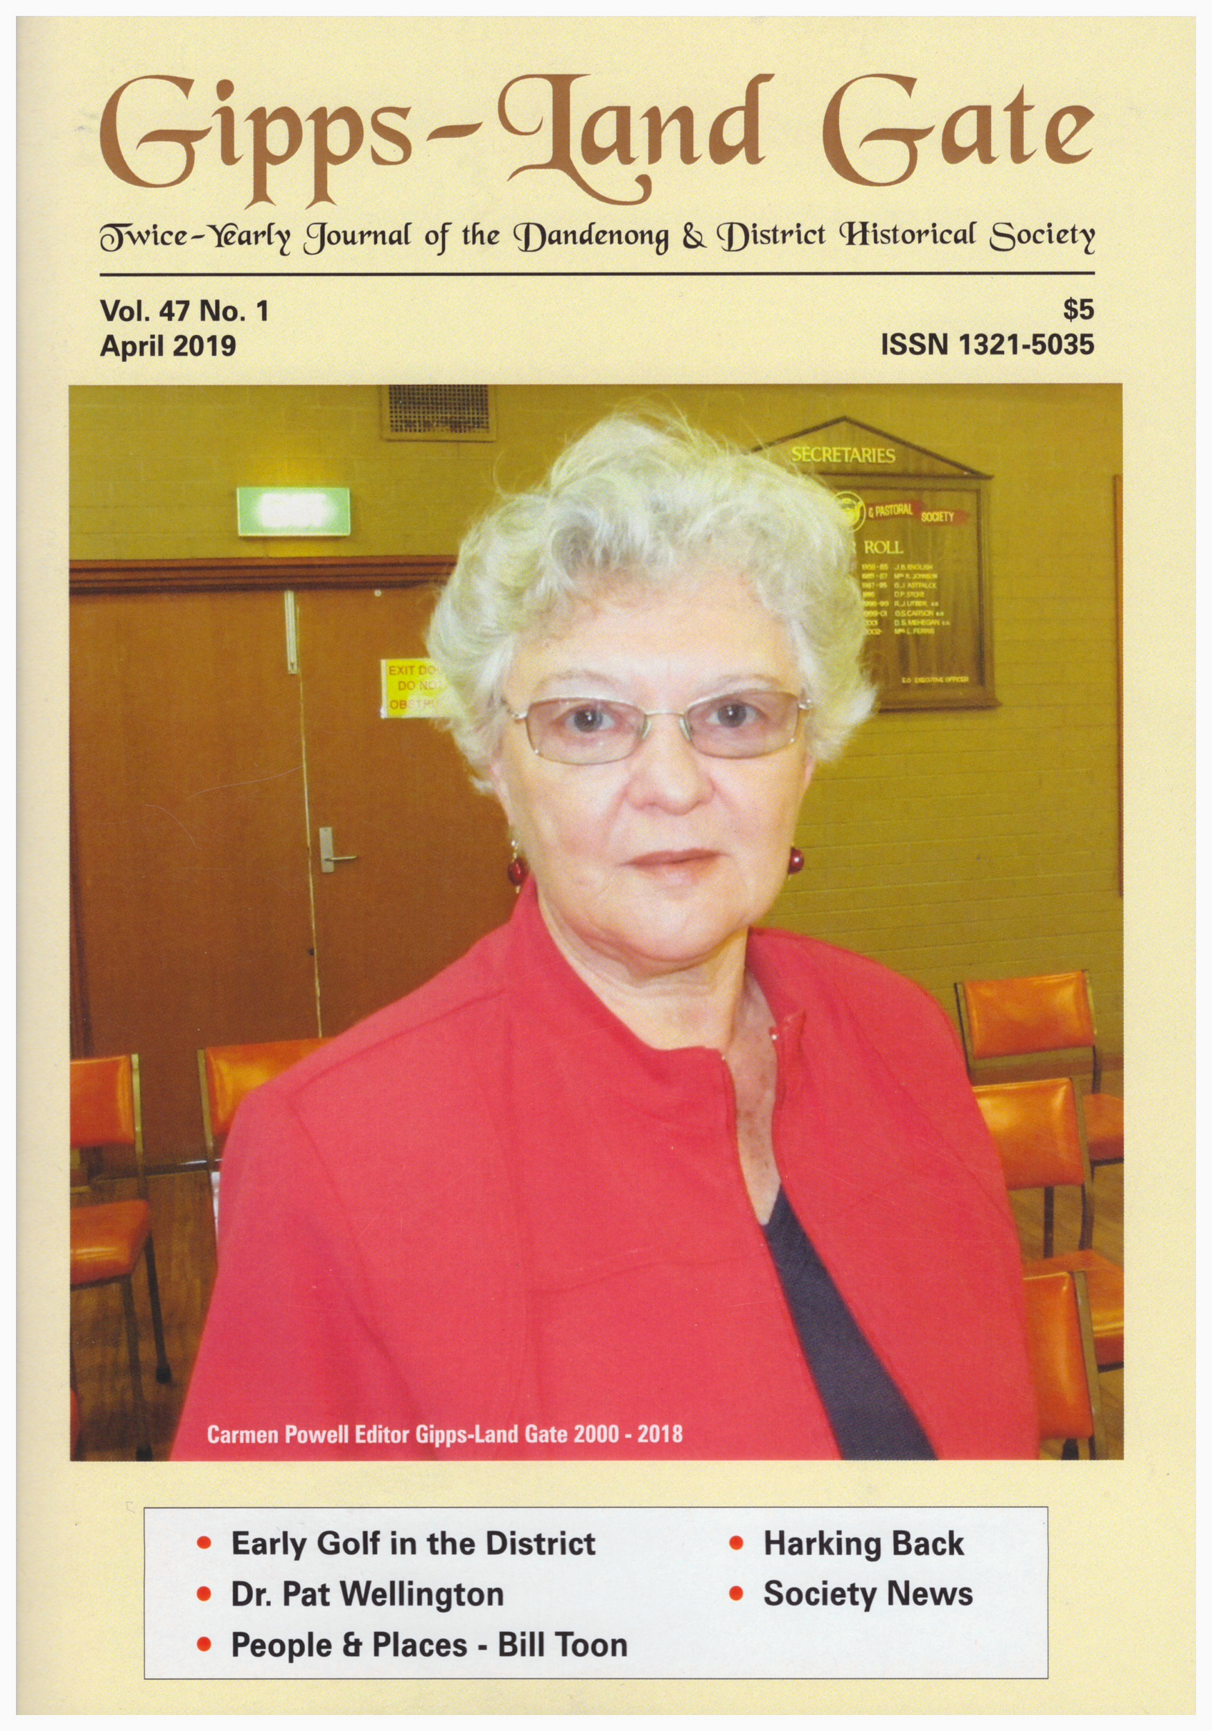
Retirement of the Gipps –Land gate – Chris Keys
Early Golf in the District –Extracts from History of the Kingswood Golf Club by Mark Harding
Dr Pat Wellington – Extracts from “Memoirs 1913-1954 by Pat Wellington
People and Places – J W H (Bill) Toon OAM KSJ
Harking Back - Bev Pursell

Dandenong Historical Society

Headquarters and Resource Centre: Level 1 39 Clow Street Dandenong PO Box 8029 Dandenong 3175
email address : dandhist@internode.on.net
www.ddhs.com.au

Life Members
Jenny Ferguson, Ray Carter, Carmen Powell

Chief Sponsor
Our society acknowledges with thanks the assistance of the City of Greater Dandenong in allowing us the use of our rooms at 39 Clow Street Dandenong. Archive Facility in Hammond Road and for their continuing monetary assistance

Sponsors
A special thank you to our loyal sponsor
The Dandenong Club

Contacts
Note: Please leave a message on our answering machine and we will endeavour to get back to you within the week.
Ph (03) 9794 8967

